**Capstone project Screenshots –**

**Balasubramanya Gokere Satish**

**1882267**

[**b.gokeresatish@tcs.com**](mailto:b.gokeresatish@tcs.com)

**GitHub link –** [**https://github.com/1994balu/capstonefinal.git**](https://github.com/1994balu/capstonefinal.git)

1. **Admin Portal Outline -**

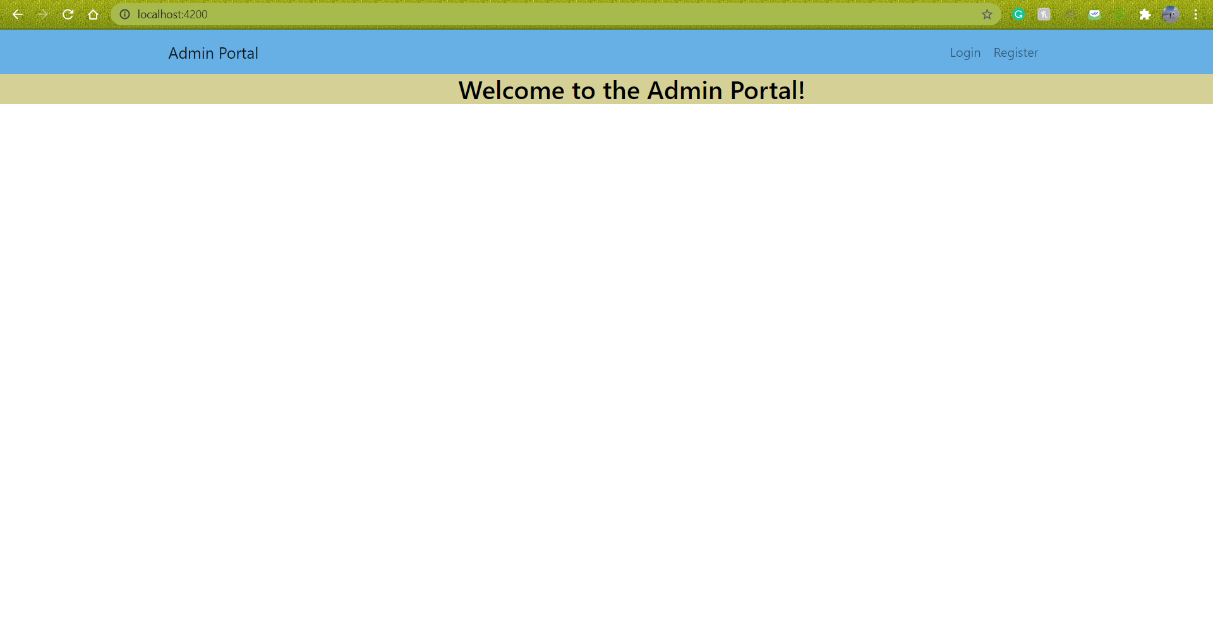

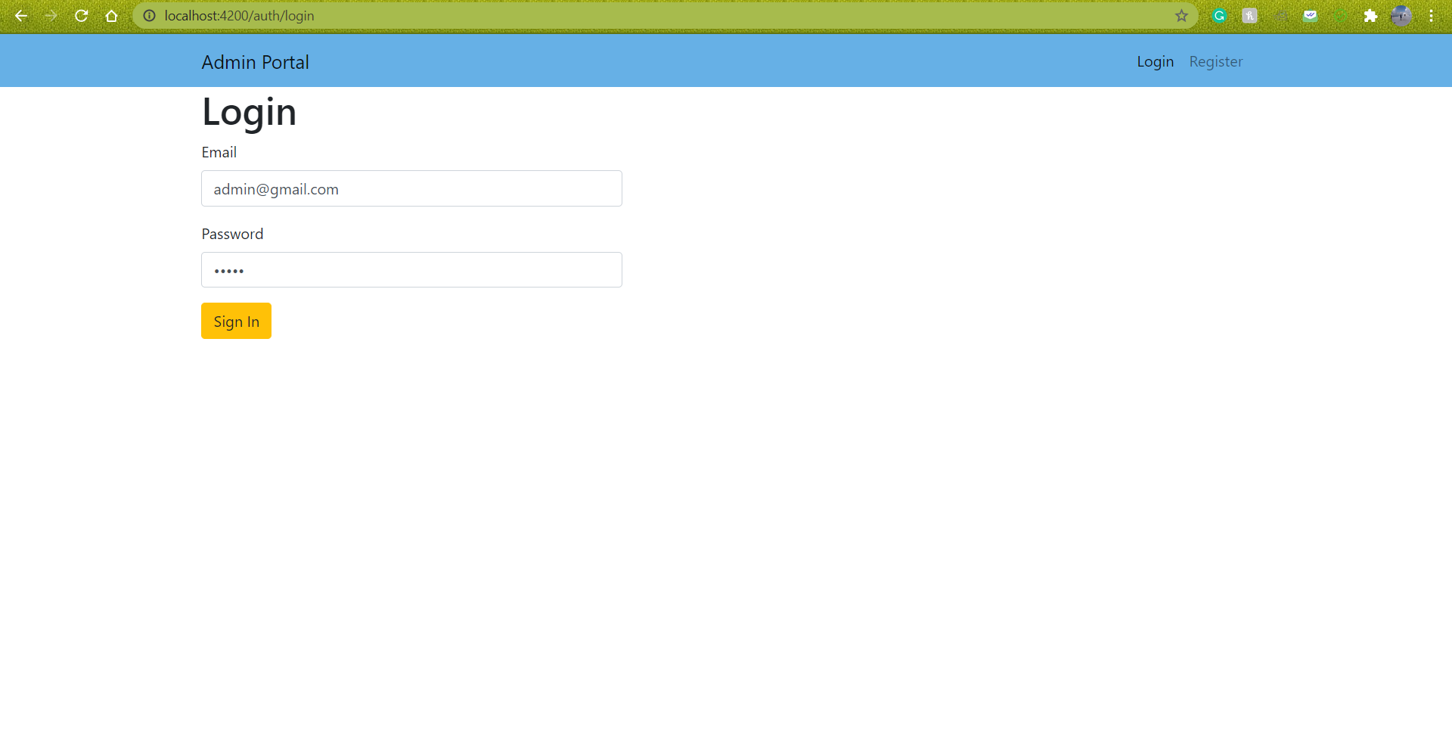

Admin must only login using [admin@gmail.com](mailto:admin@gmail.com) and password – admin and cannot use other credentials.

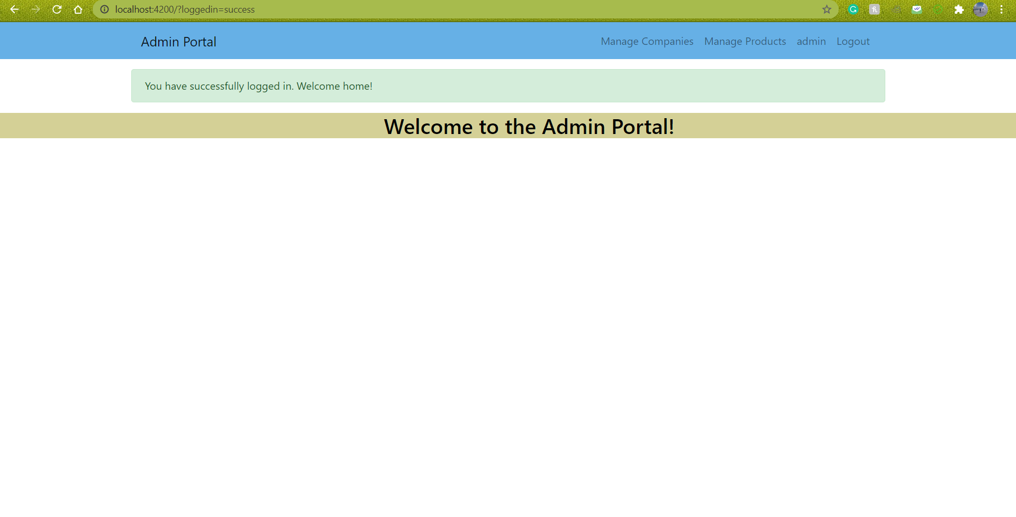

**Companies – CRUD**

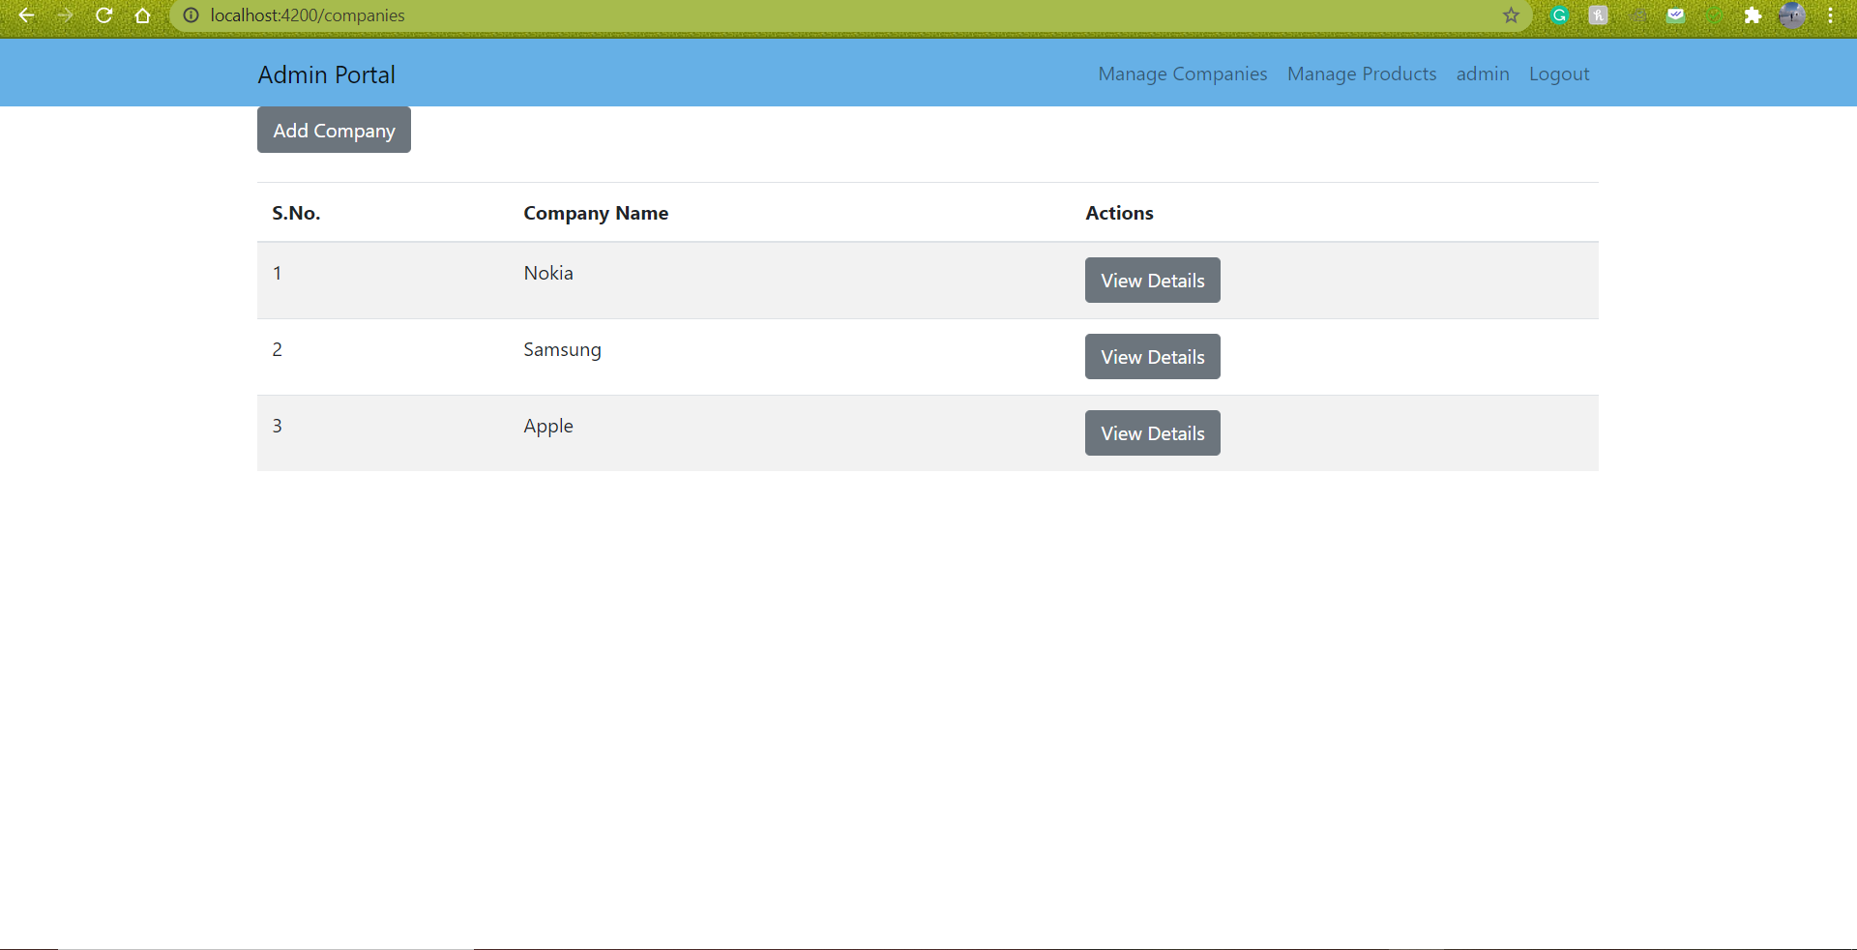

* I am now going to add another company to the list –

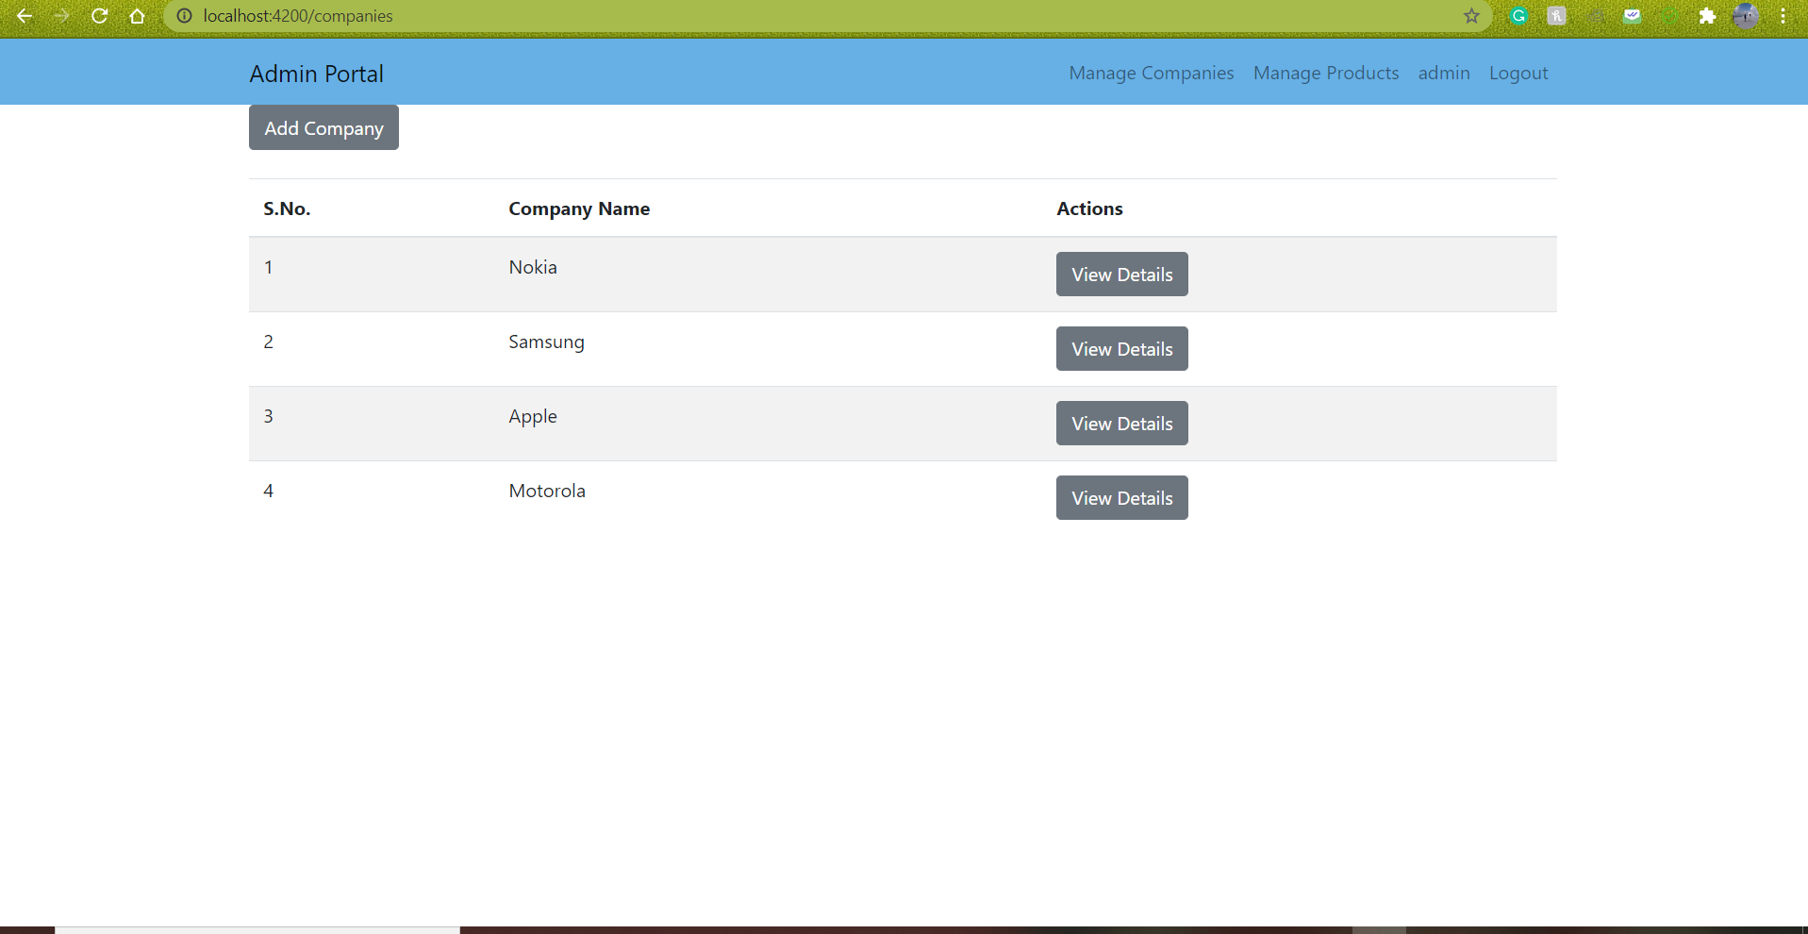

As you can see, I have added Motorola to the list of companies.

* Updating the existing company

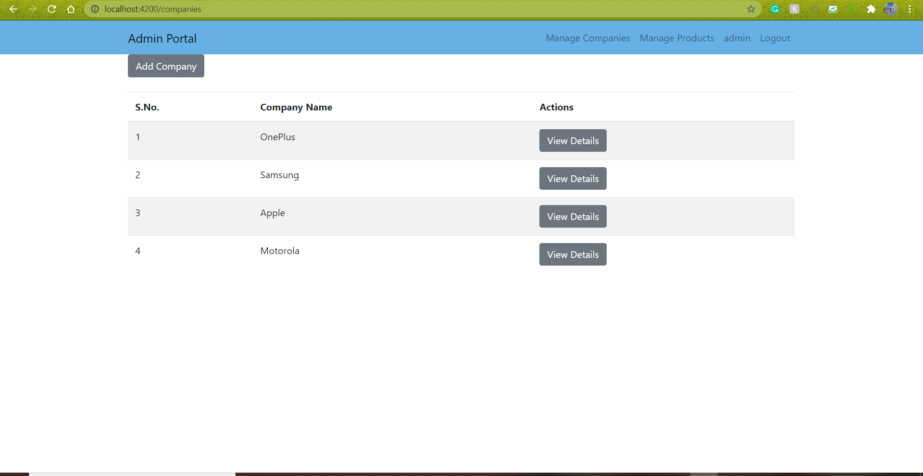

As you can see, I have updated Nokia to OnePlus.

* Deleting an existing company from the list

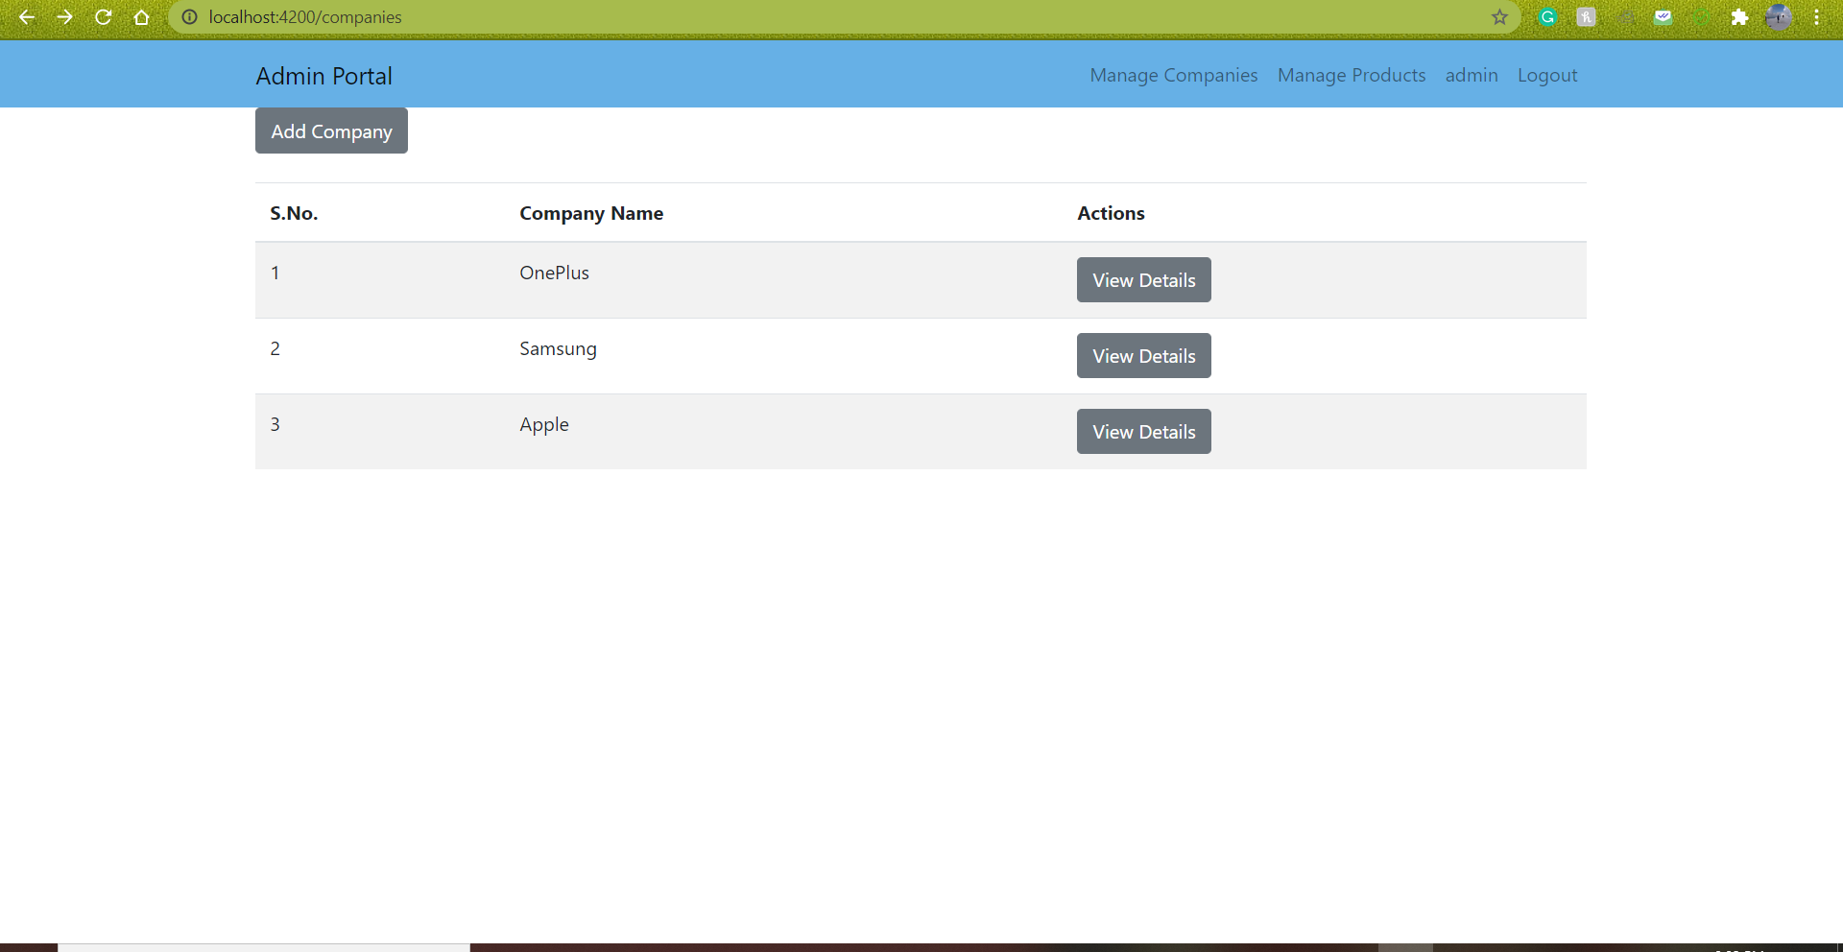

I have deleted Motorola from the list.

**Products – CRUD**

* There is already one product in the list of products, I am going to add few more.

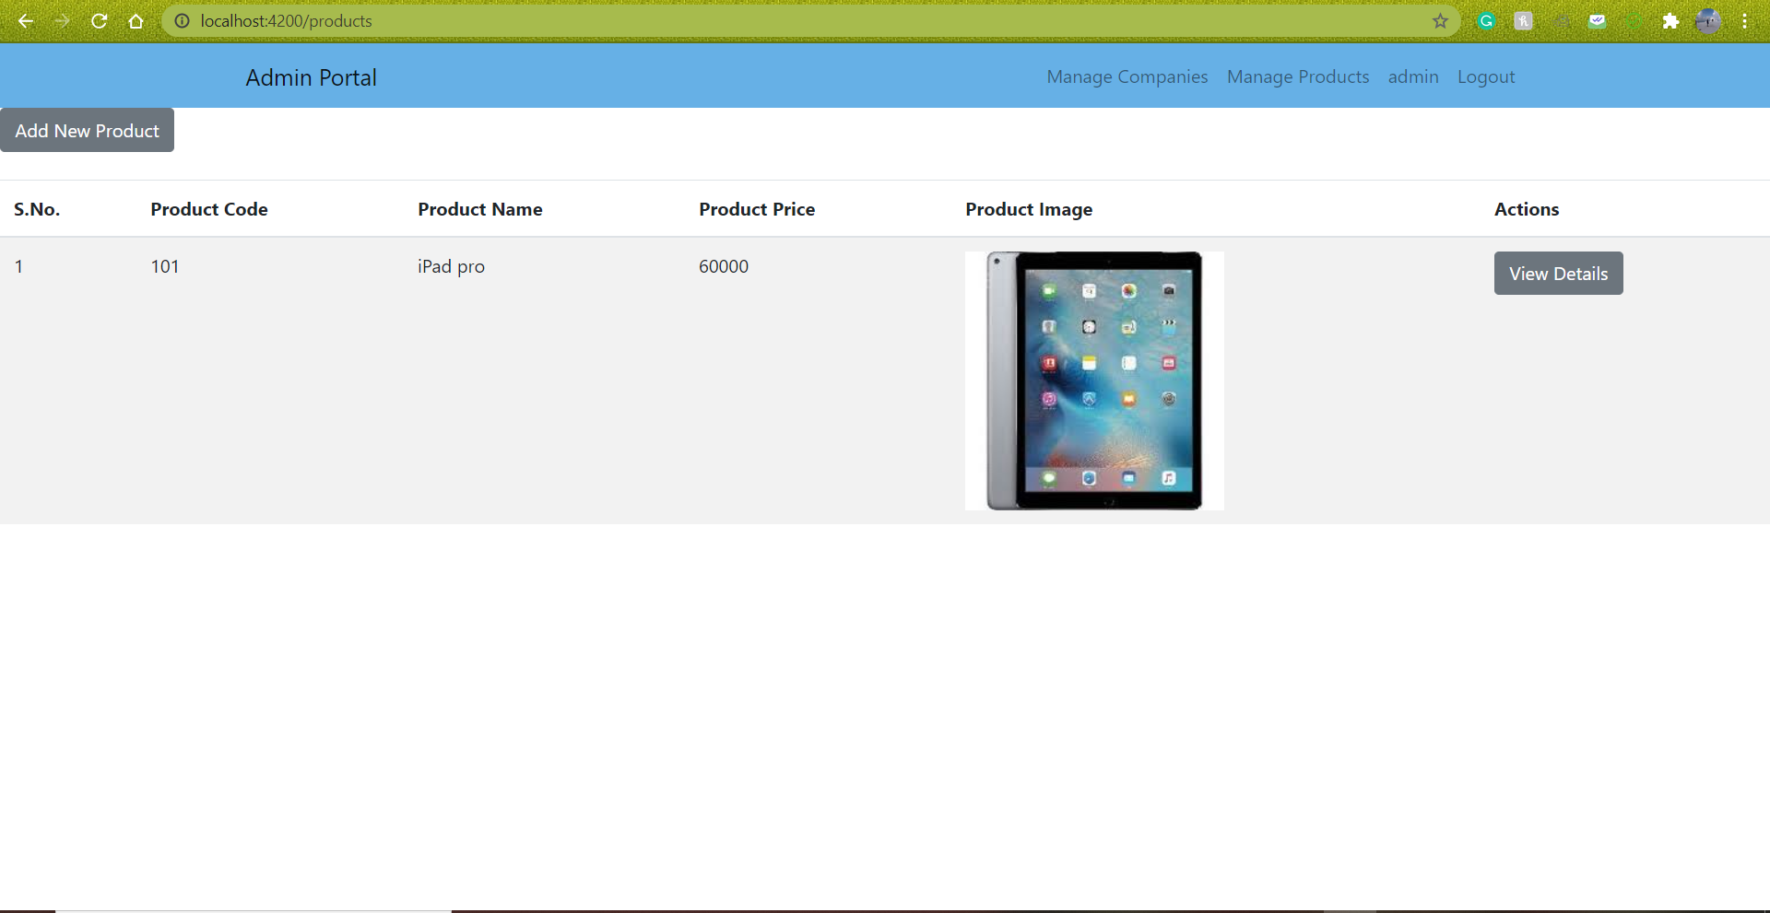

* Adding a new product

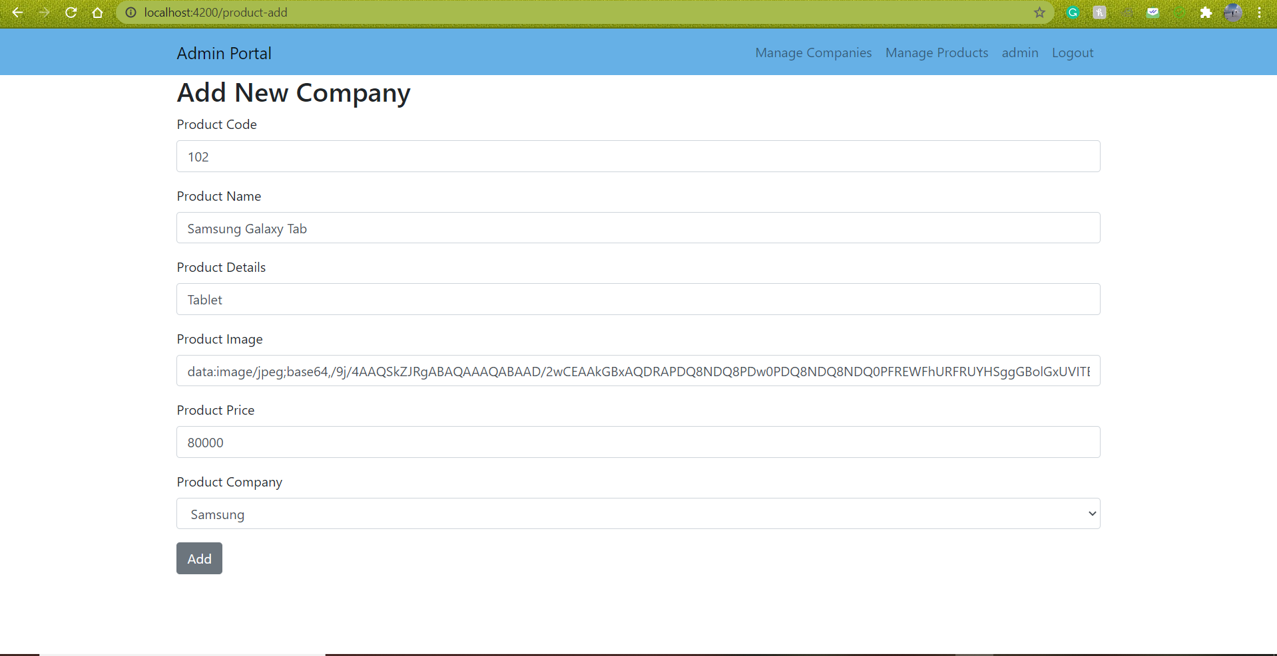

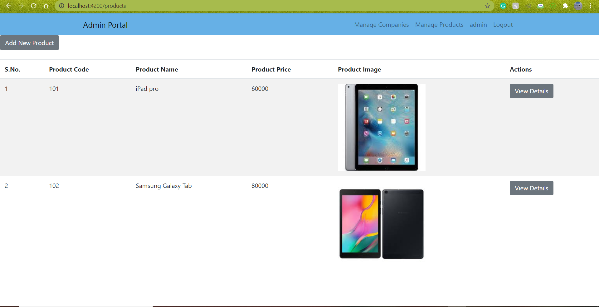

* Deleting a product from the list of products

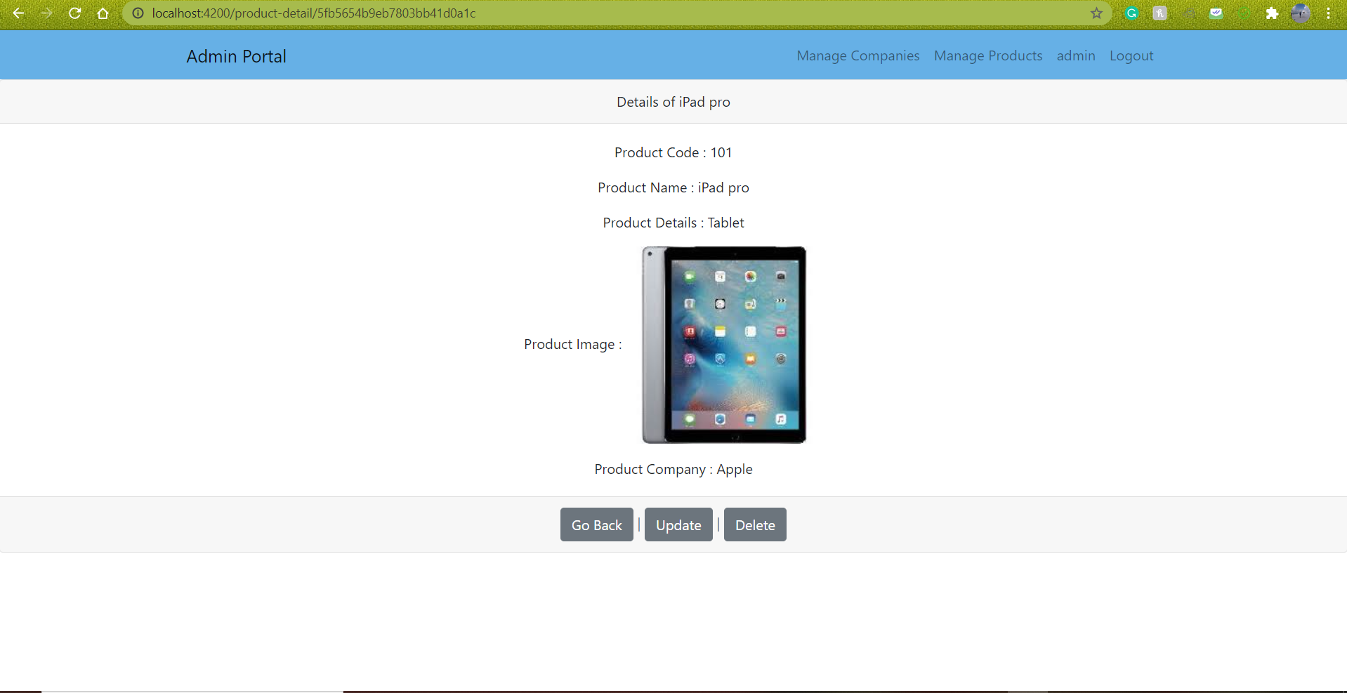

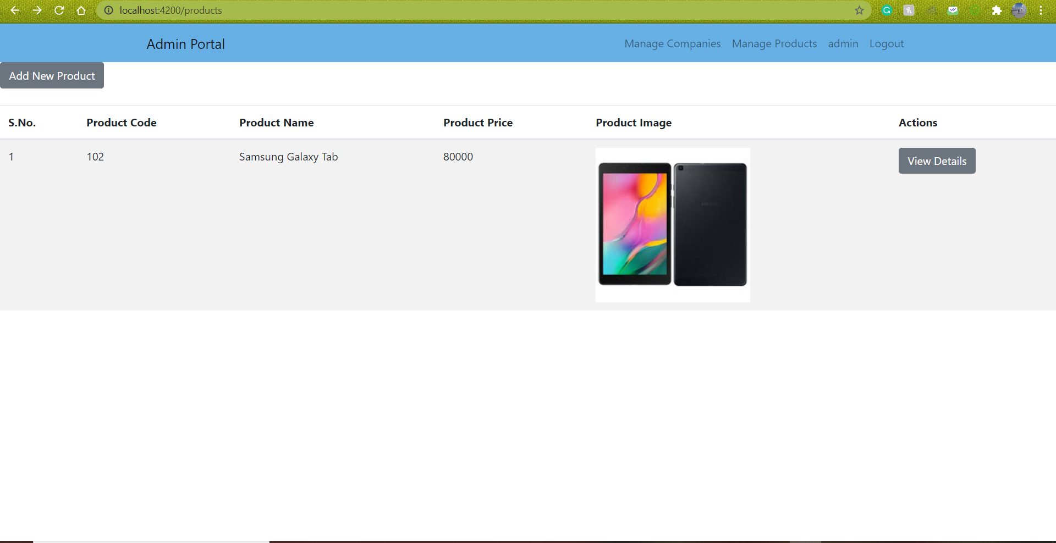

As you can see, I have deleted iPad pro from the list. The updated product list show above.

* In addition, I have added few more products to the list of products.

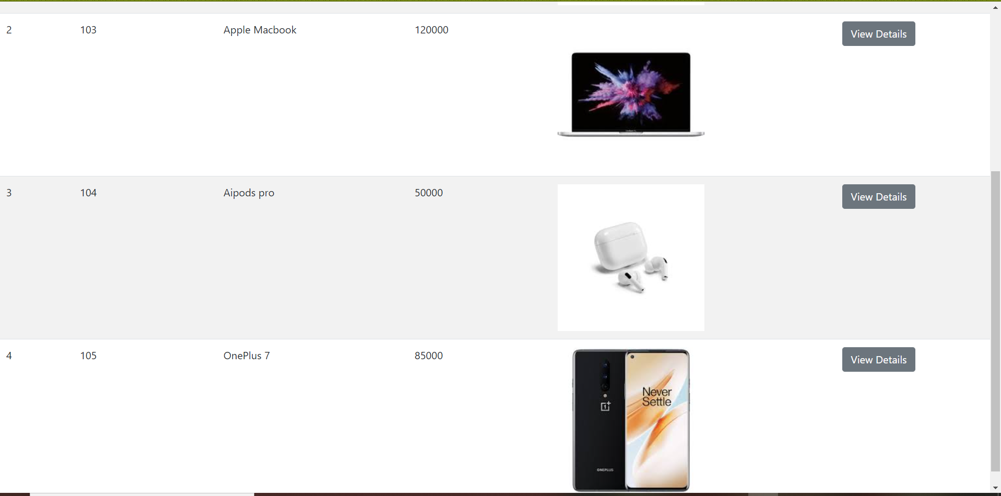

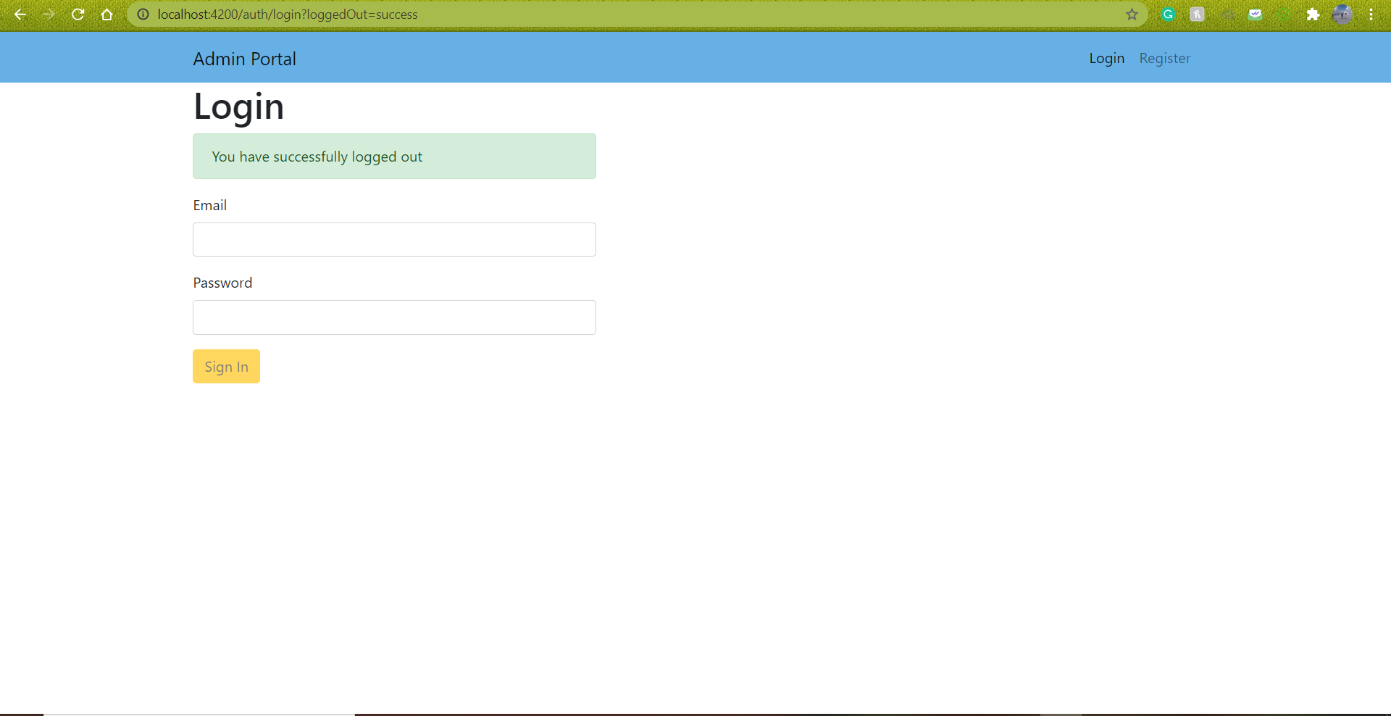

1. **User Portal Outline –**

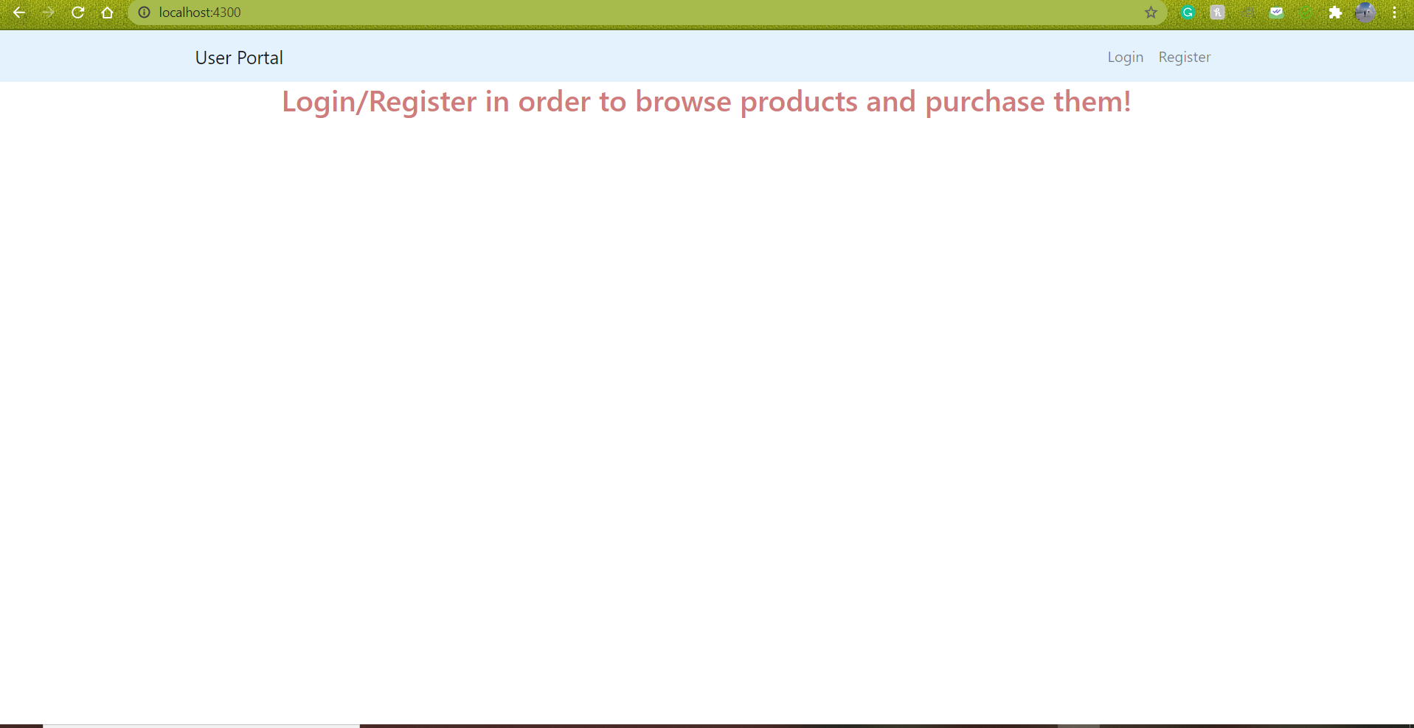

* I have logged in using [balu@gmail.com](mailto:balu@gmail.com) and password – 12345

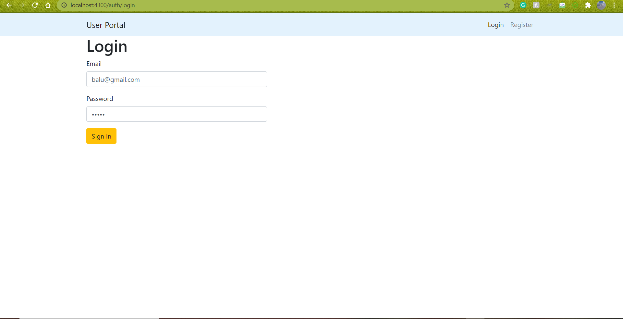

* Products list view

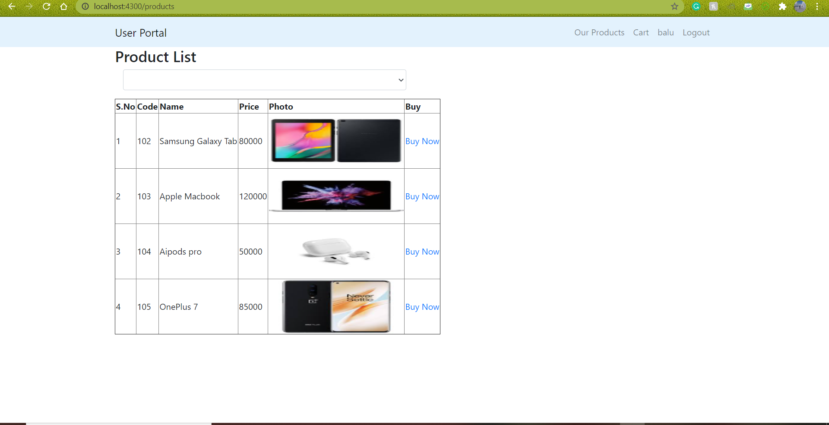

* I will be able to sort products based on the companies which is shown below –

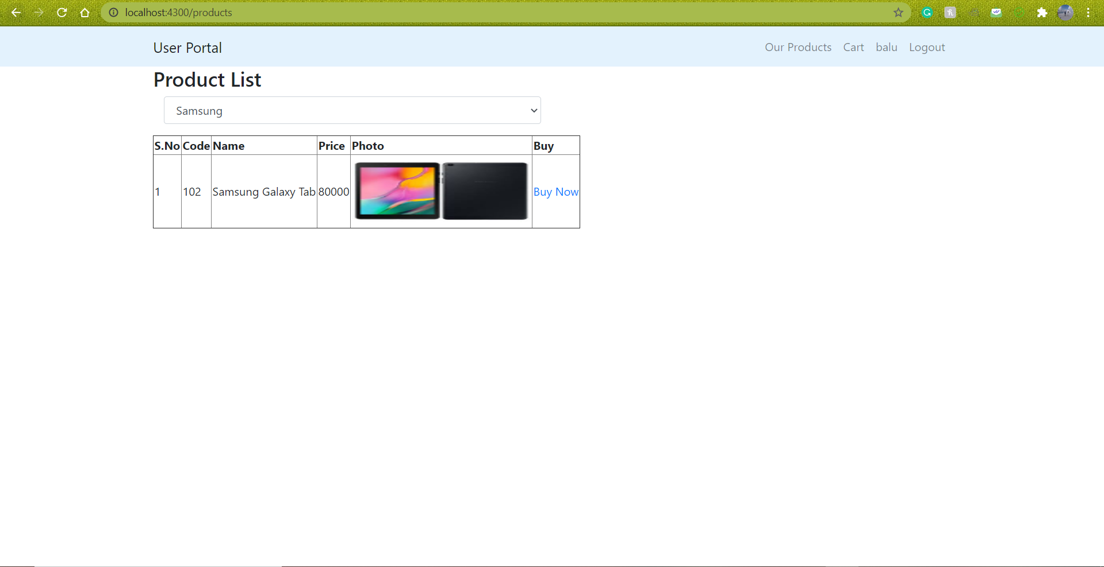

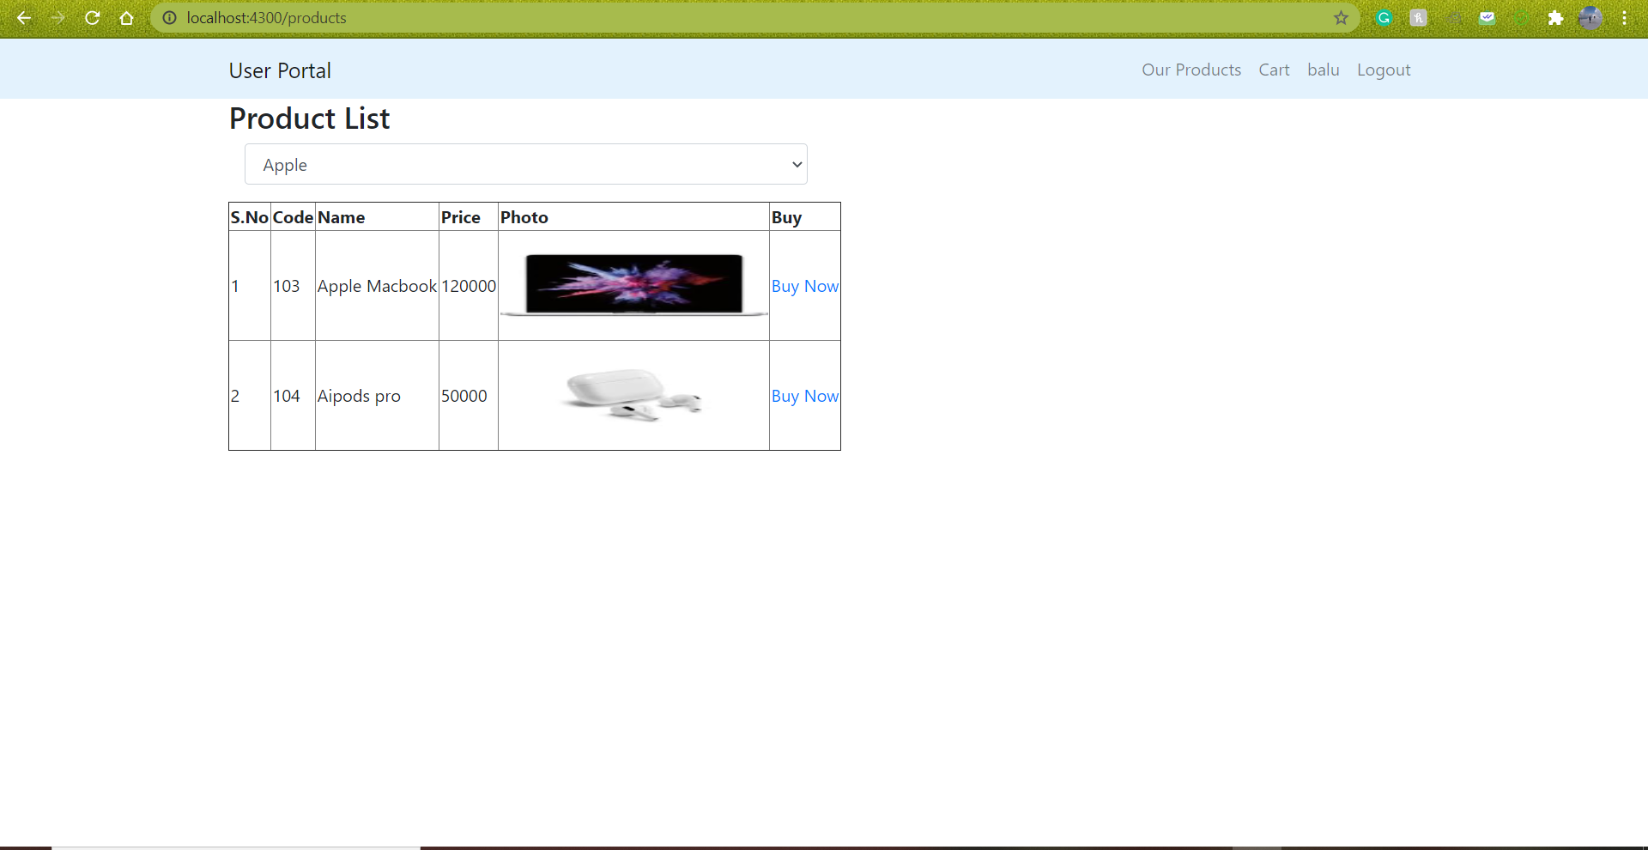

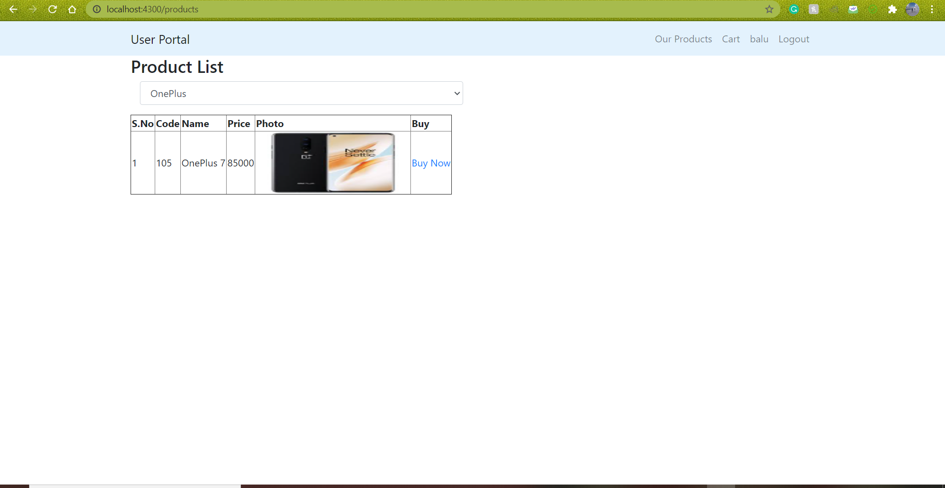

* Adding products to the cart

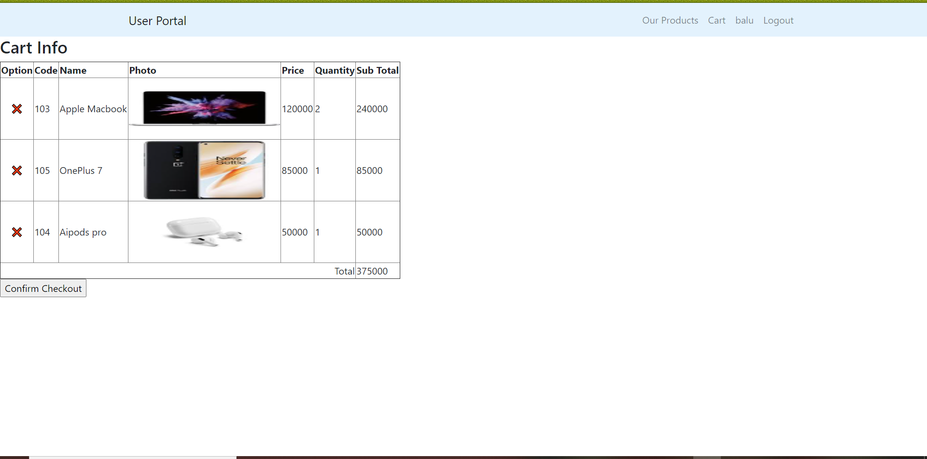

* I will delete one product – Apple Macbook from the cart and the updated cart is shown below –

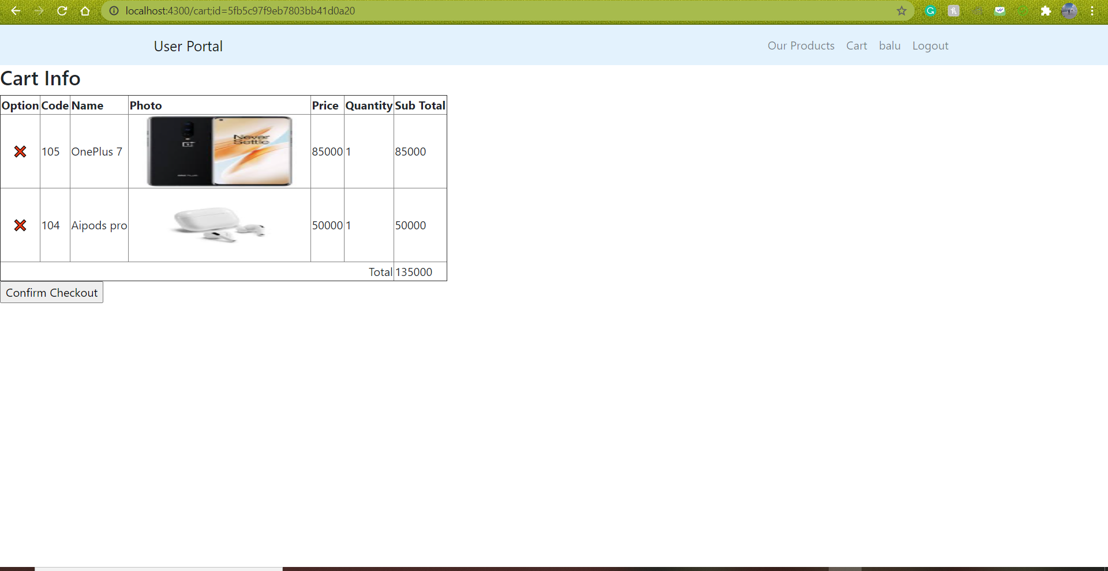

* Checkout page

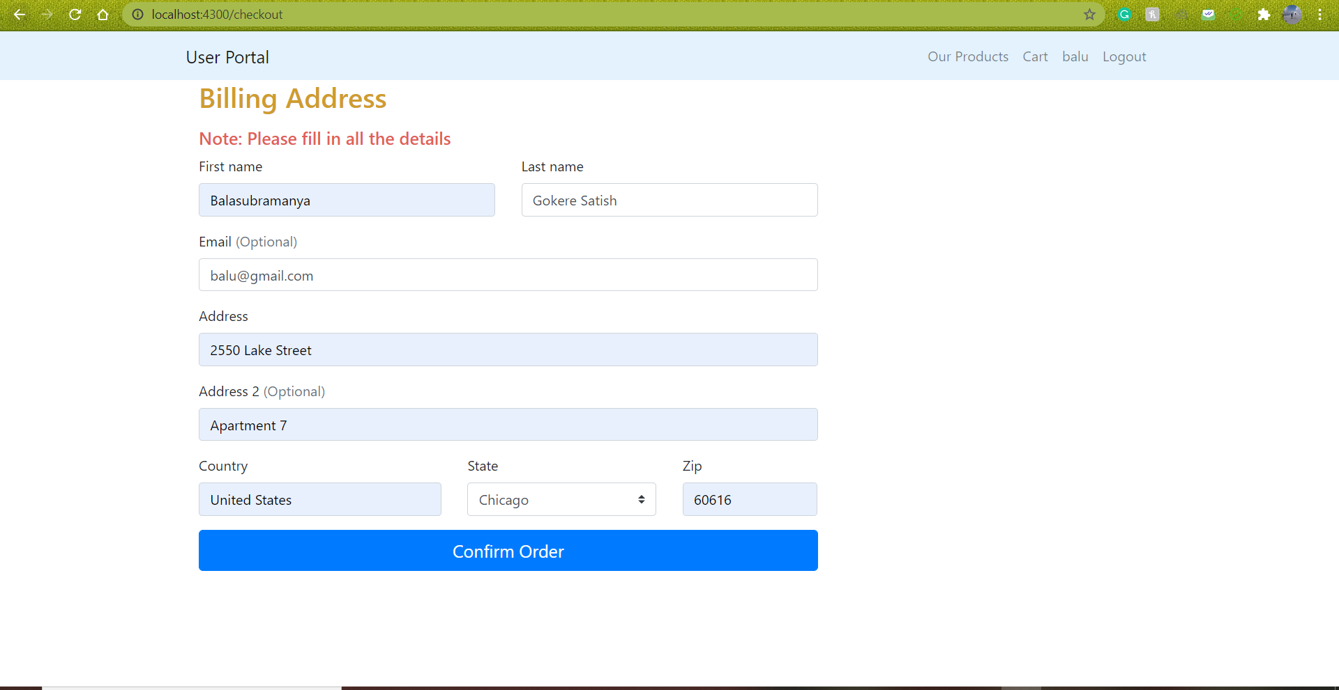

After confirming the order, the below message will be displayed.

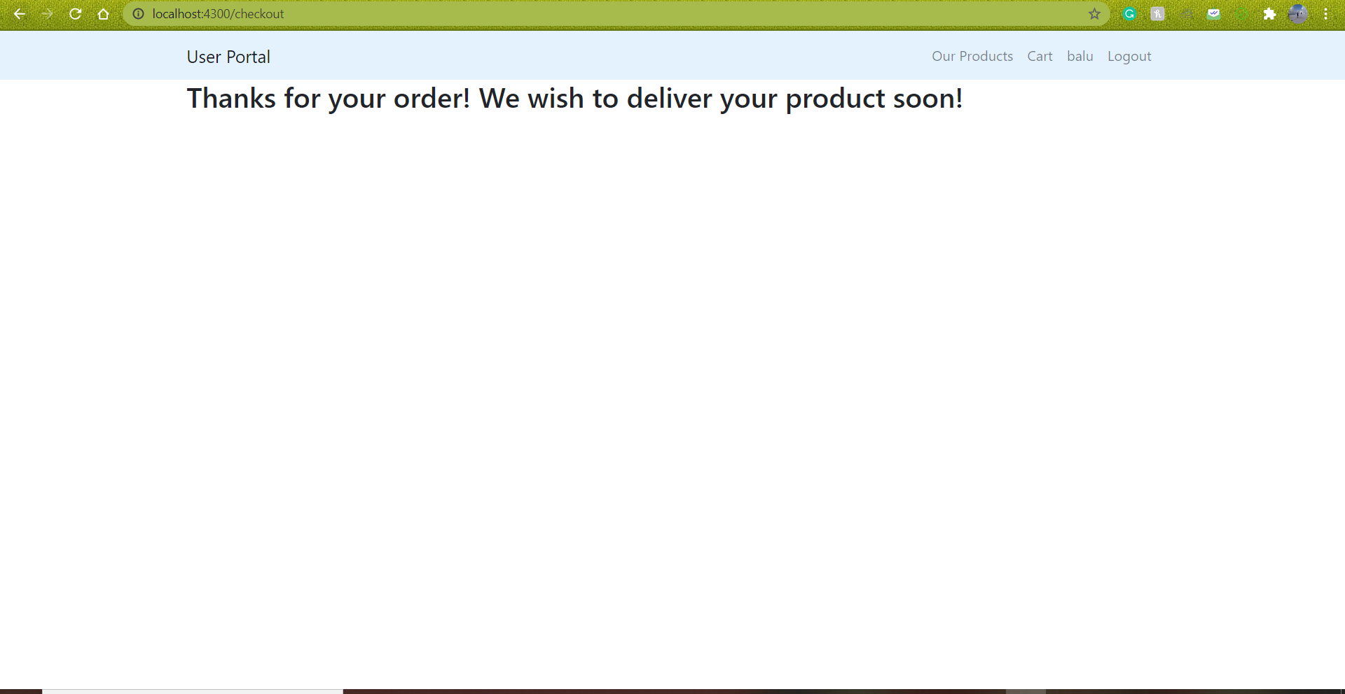

User after successfully logging out –

